**Hub with 2 spokes Connection:**

Step1: Create Virtual networks hub-vnet, spoke1-vnet, spoke2-vnet, spoke3-vnet

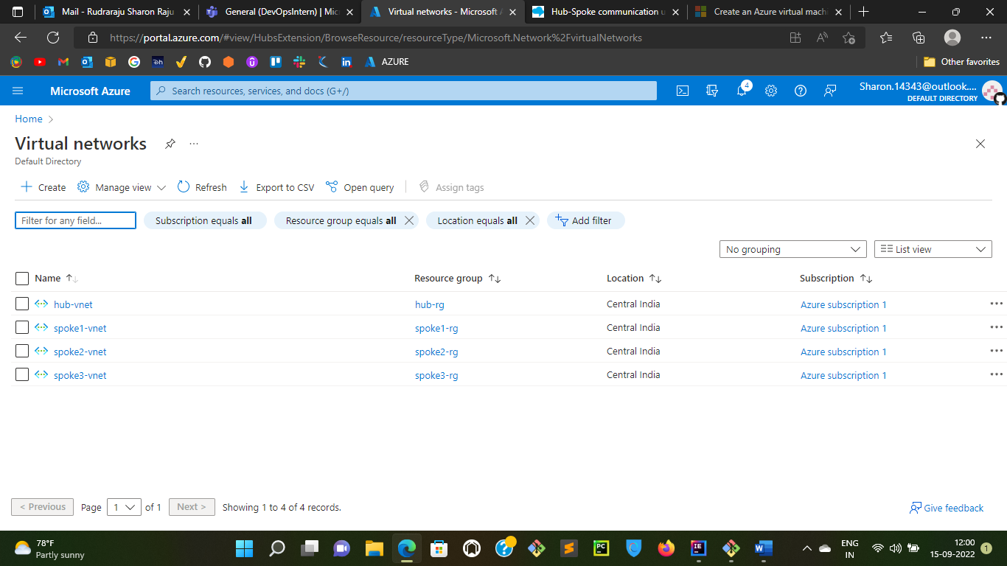

Step2: Setup Vnet peering between hub-spoke1, hub-spoke2, hub-spoke3 at hub level and this will also make automatic vnet peering spoke1-hub, spoke2-hub, spoke3-hub

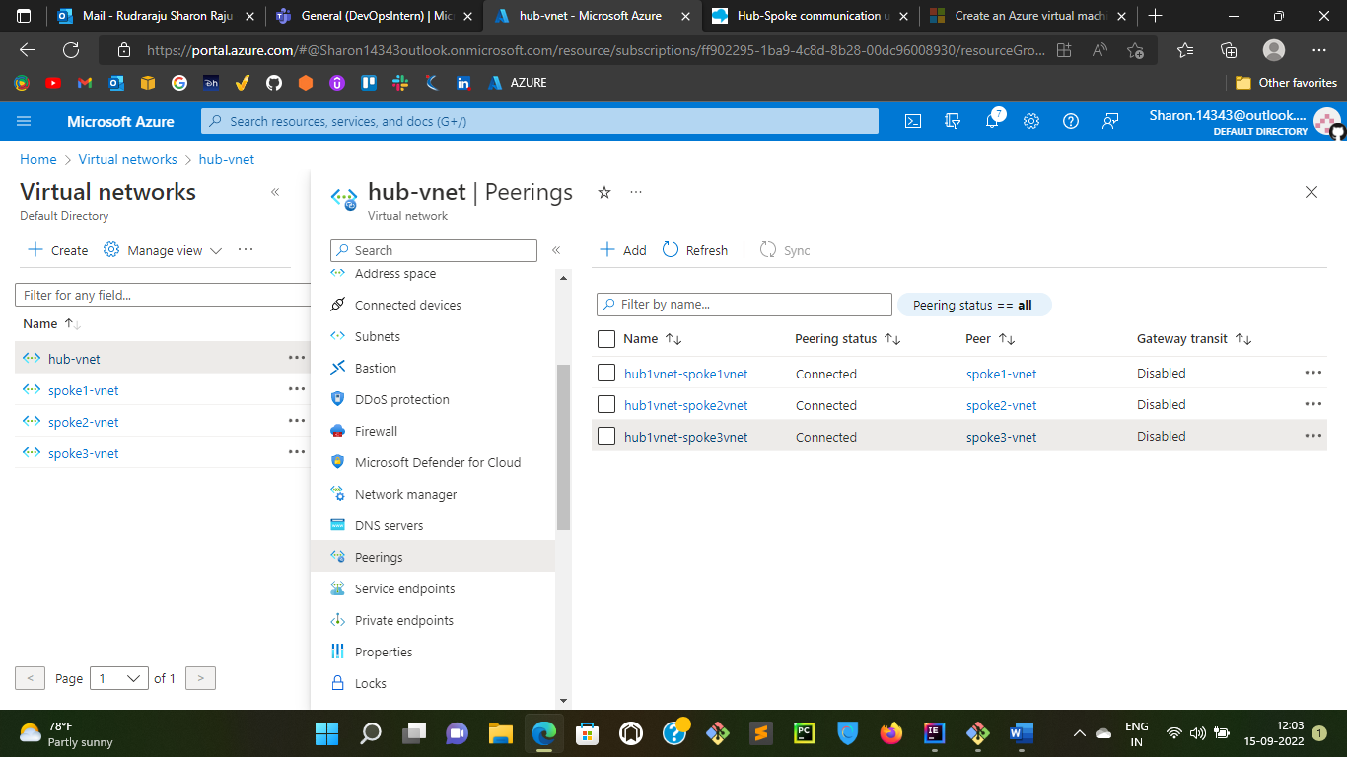

Step3: Create a Virtual Network Gateway and attach it to hub-vnet

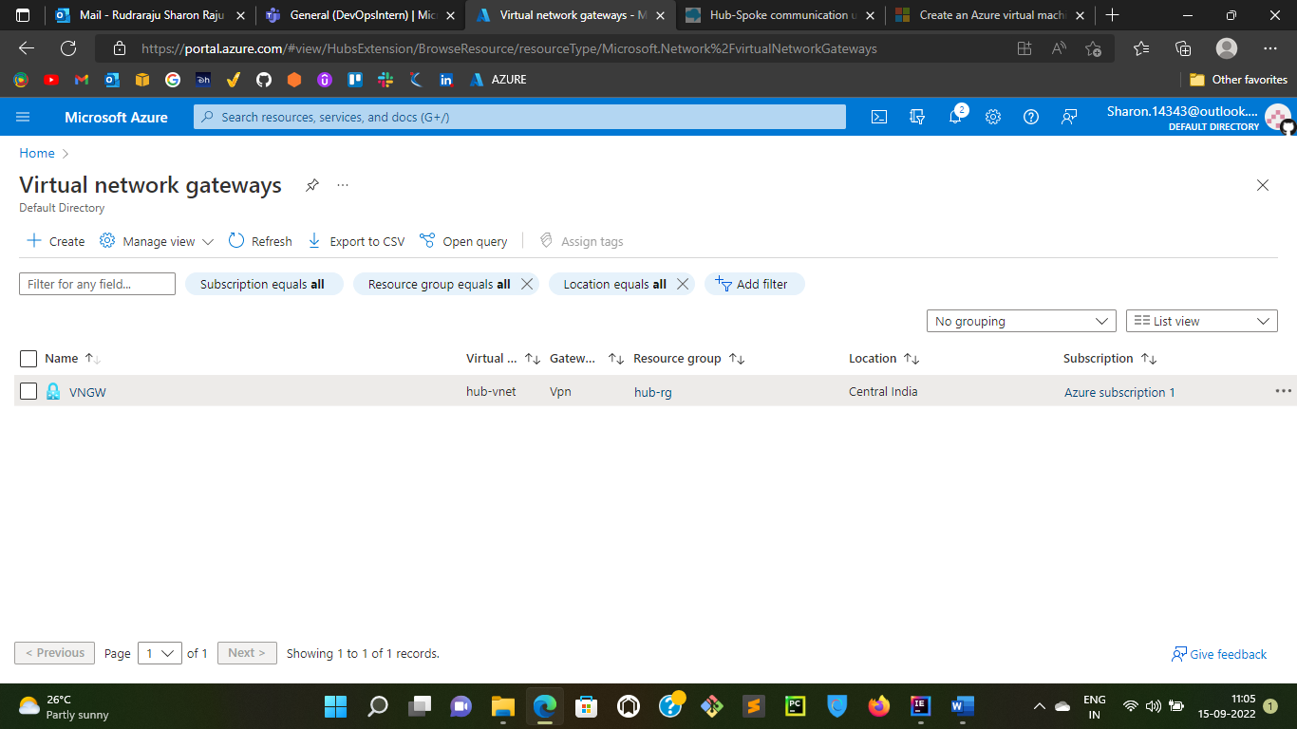

Step4: Now attach virtual network gateway as shown below

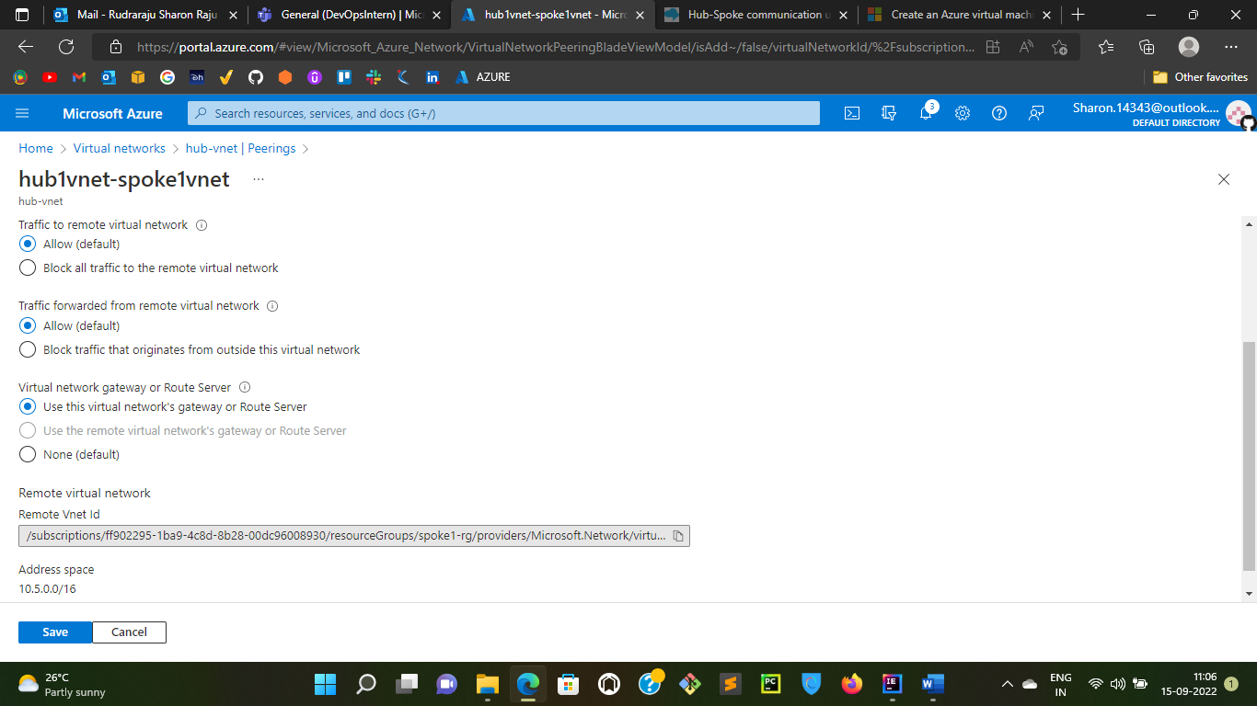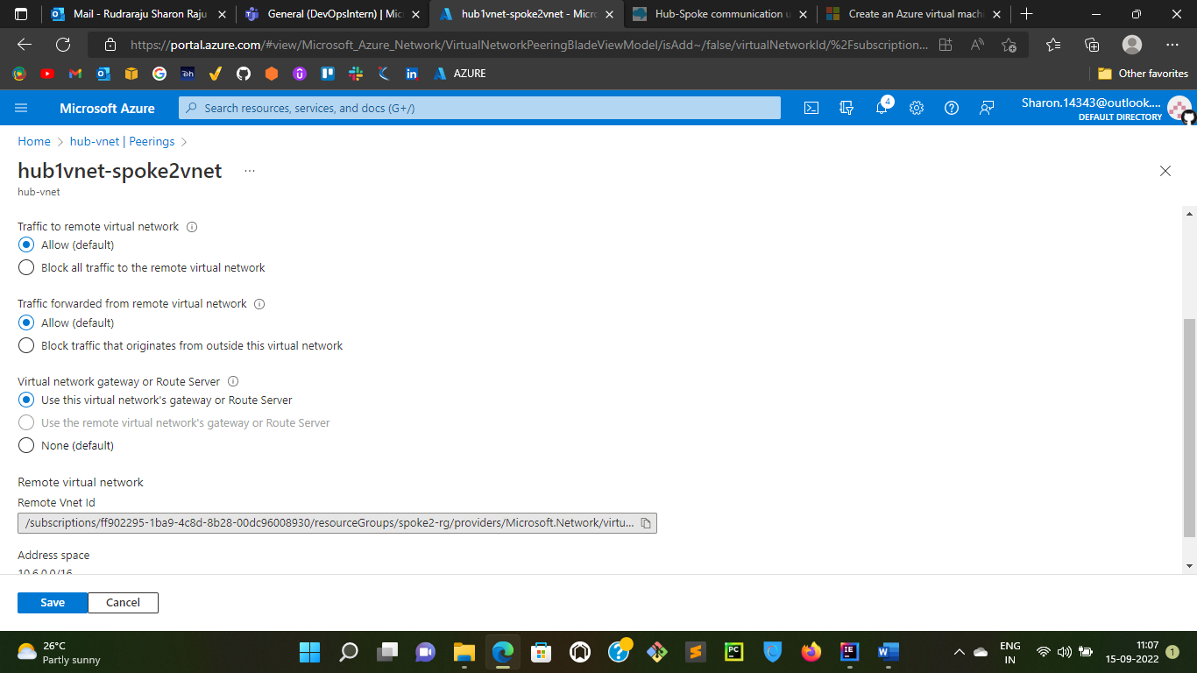

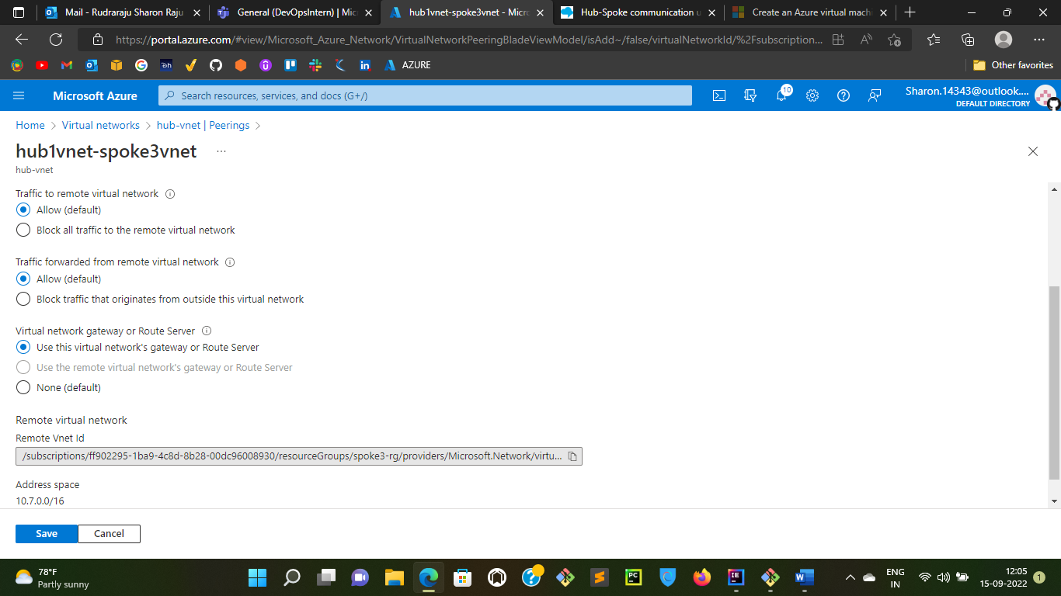

Now if you observe, Step2 picture and the picture below you can differentiate that Gateway Transit has been enabled now

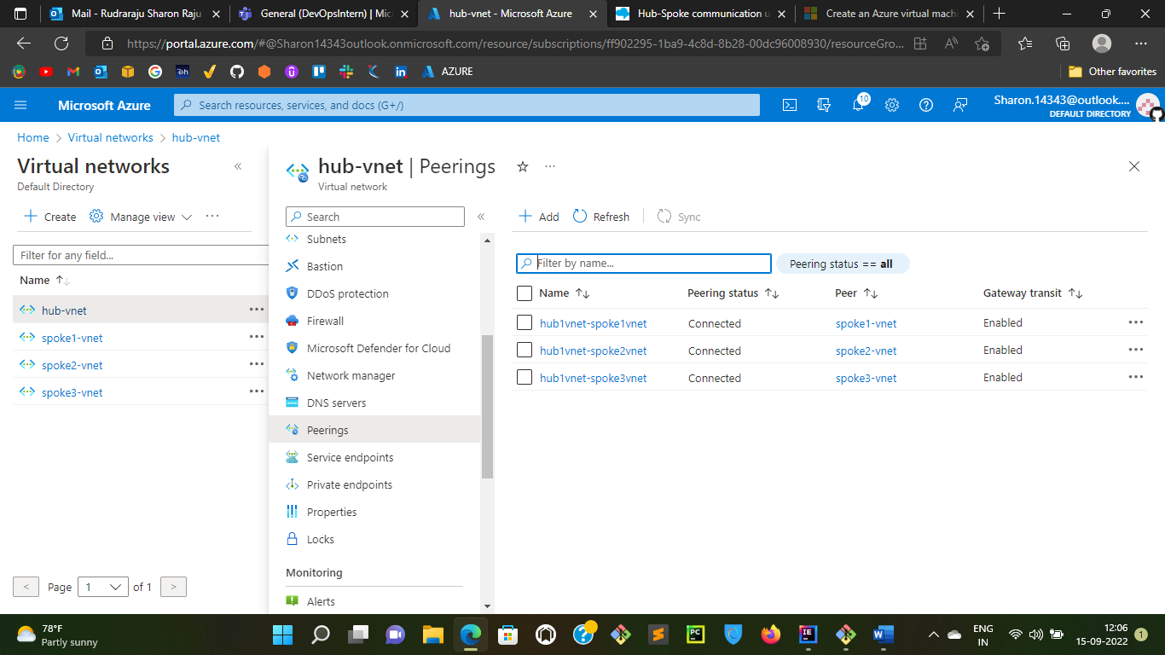

Step5: Now create route tables as shown below for Spoke1, Spoke2. Spoke3

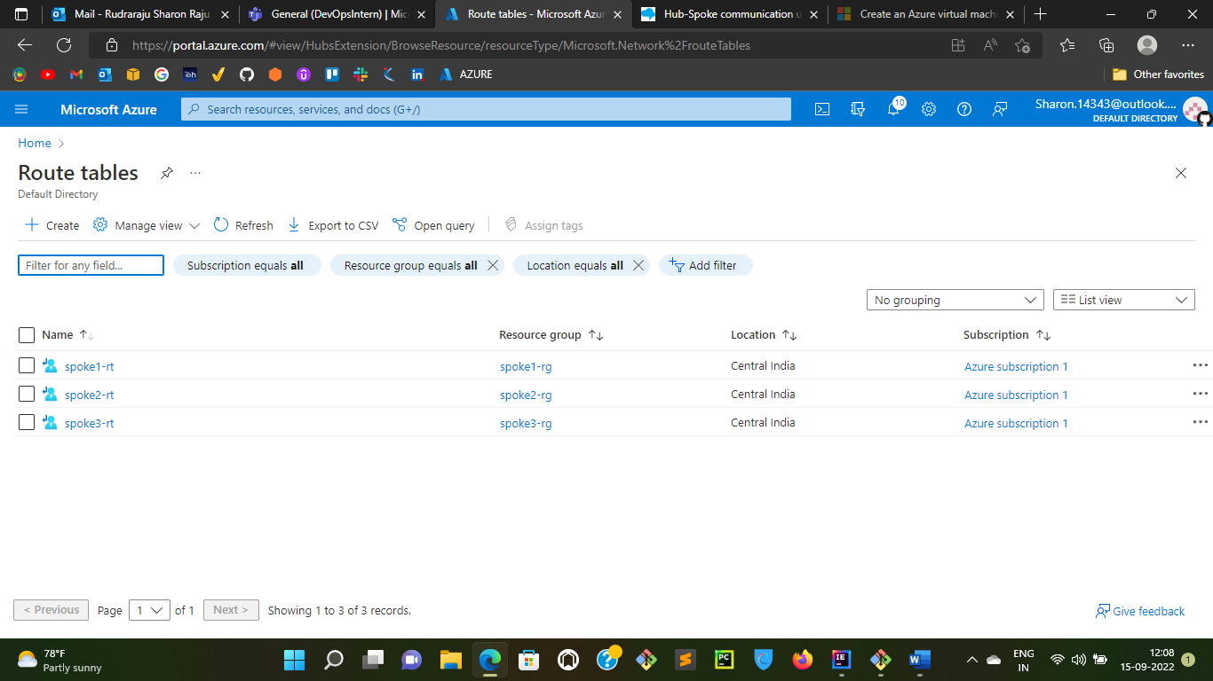

Step6: Now create the routes for the above route tables as shown below

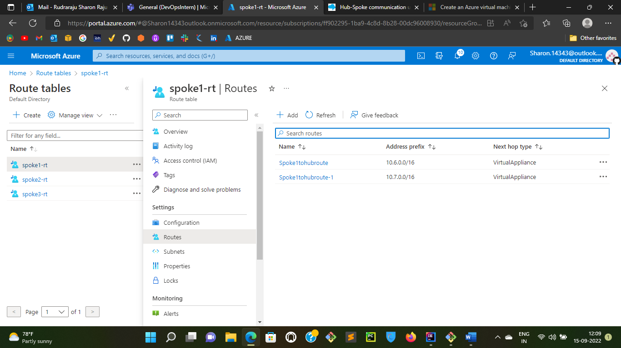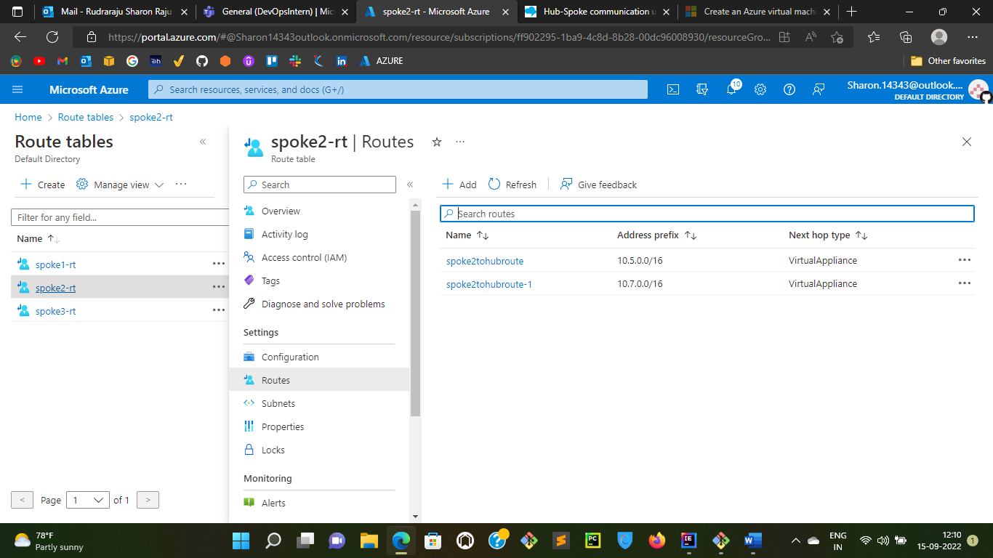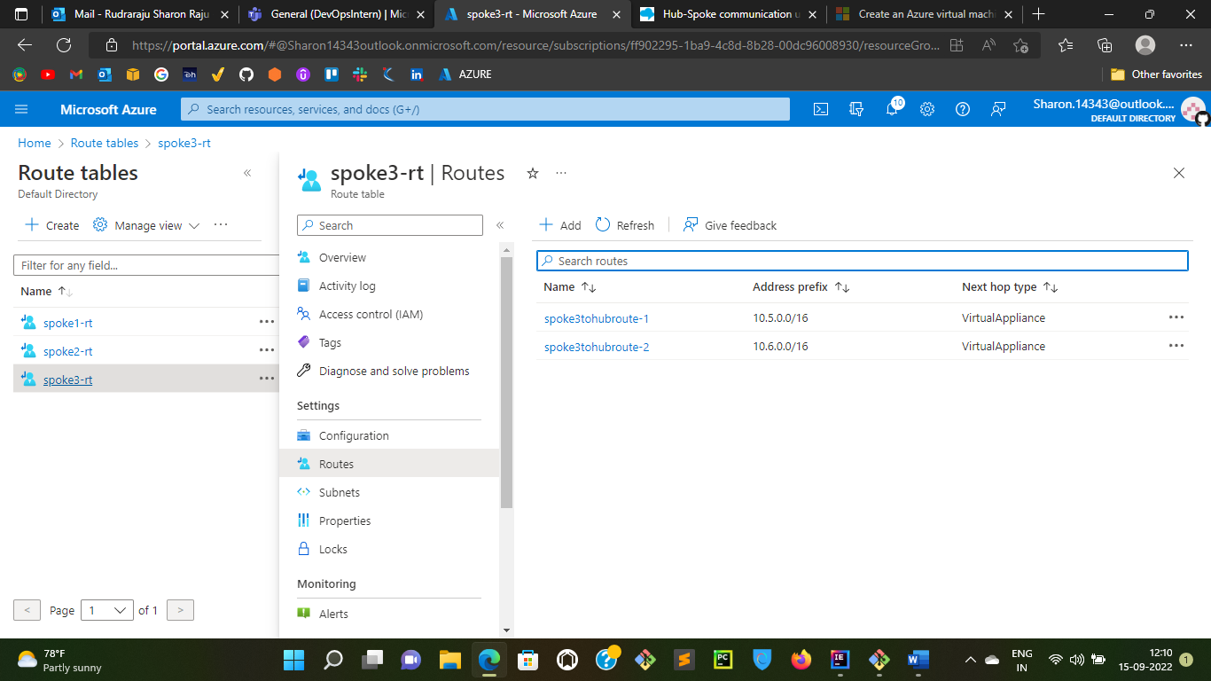

Step7: Now add these route tables to the spoke1-subnet and spoke2-subnet as shown below

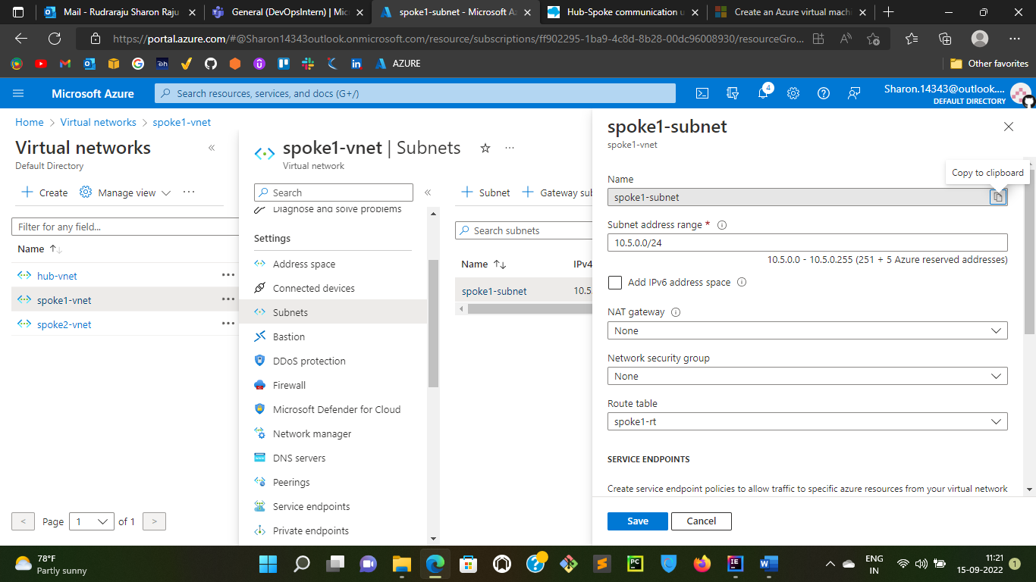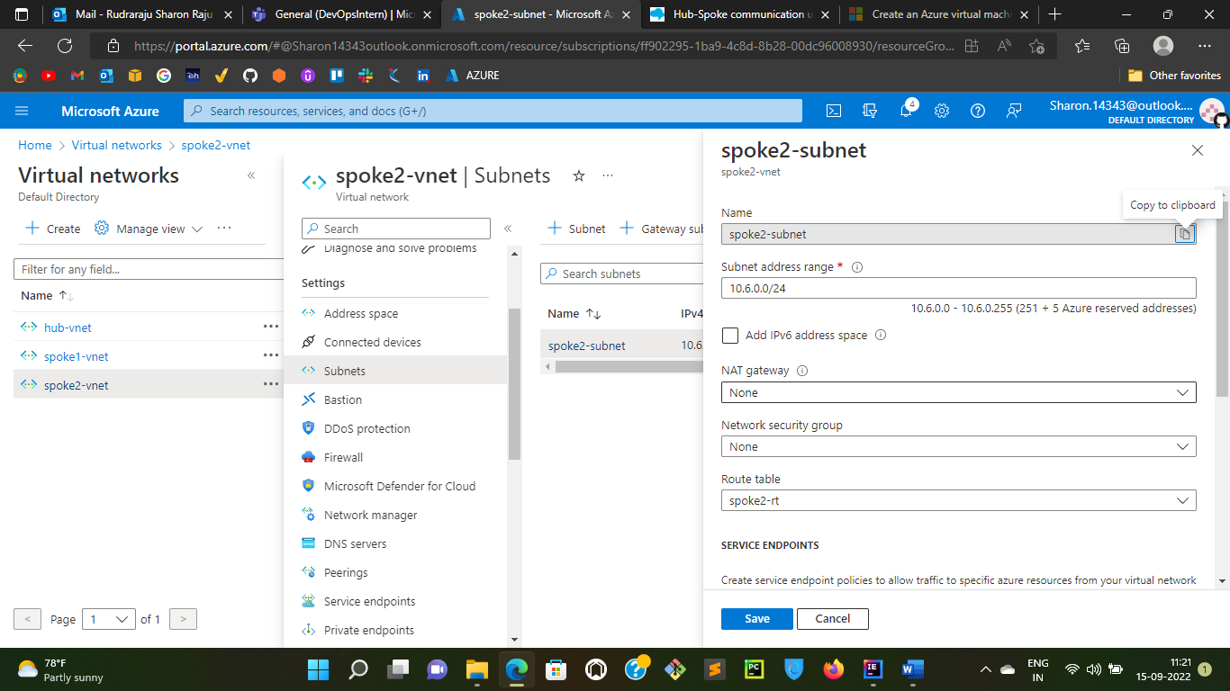

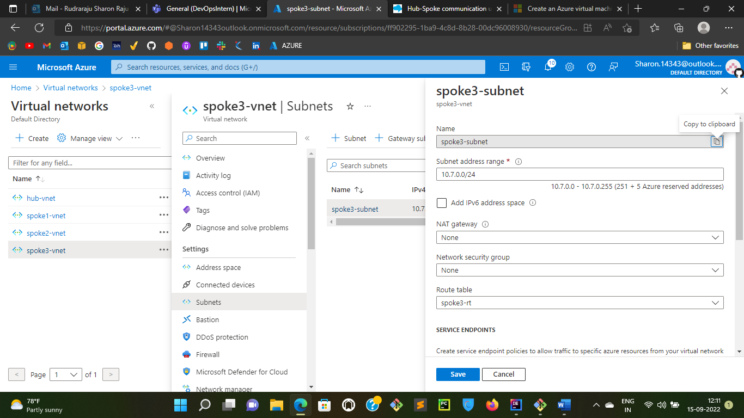

Step8: Now Create Virtual Machines for hub, spoke1, spoke2 andspoke3 and the test the communication. If the communication is successful then the hub and spoke model implemented above is working fine. In this case, I have logged into spoke3-vm and tested the command ping 10.6.0.0 and ping 10.5.0.0 i.e., spoke 2 vm private Ip and spoke 1 vm private Ip respectively. So, we can see the packets and sent and received successfully so the hub and spoke implementation is working.

